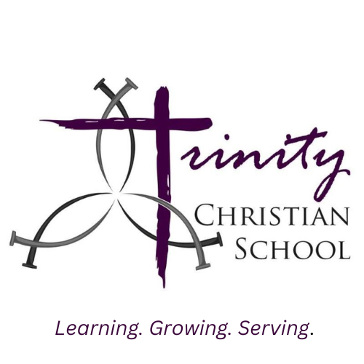

146 Reserve Road West Seneca, NY 14224

(716) 674-5353

www.trinitywny.org

**COST OF EDUCATION FOR THE 2025-2026 SCHOOL YEAR**

**PRESCHOOL**

**PRE-KINDERGARTEN 4**

**5 Full Days $4,700.00 8:45 am-2:30 pm**

**5 Half Days $4,000.00 8:45 am-11:45 am**

**PRESCHOOL 3**

**3 Day M-W-F (Full Day) $3,500.00 8:45 am-2:30 pm**

**3 Day M-W-F (Half Day) $3,200.00 8:45 am-11:45 am**

**Please visit** [**www.trinitywny.org**](http://www.trinitywny.org) **to enroll.**

*The mission of Trinity Christian School is to guide our children in faith, learning, character and leadership by nurturing their relationship with Jesus Christ and educating them for a lifetime of service to God and man.*