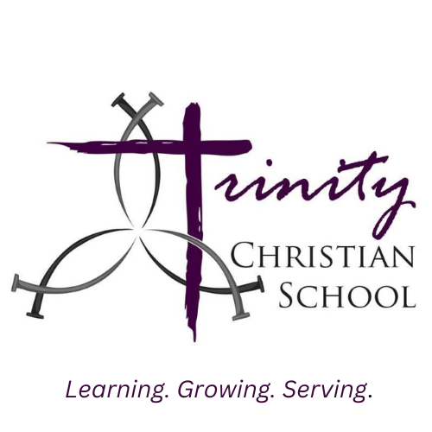
146 Reserve Road West Seneca, NY 14224
(716) 674-5353
www.trinitywny.org

COST OF EDUCATION FOR THE 2026-2027 SCHOOL YEAR

PRESCHOOL

PRE-KINDERGARTEN 4
5 Full Days $4,900.00 8:45 am-2:30 pm
5 Half Days $4,200.00 8:45 am-11:45 am

PRESCHOOL 3
3 Day M-W-F (Full Day) $3,700.00 8:45 am-2:30 pm
3 Day M-W-F (Half Day) $3,400.00 8:45 am-11:45 am
2 Day T-Th (Full Day) $2,500.00 8:45 am-2:30 pm
2 Day T-Th (Half Day) $2,200.00 8:45 am-11:45 am

Please visit www.trinitywny.org to enroll.

The mission of Trinity Christian School is to learn, grow, and serve in the name of Jesus Christ.

